SCHOOL NAME: Liverpool Street Elementary
Address: 50 Liverpool St
Parent School Support Committee
Minutes
Date: Feb 17, 2022 Time: 6:15pm
Location: Microsoft TEAMS
PSSC Members Present:  Ronnie Stewart, Chair  Colin Curry, Vice Chair  Keri O’Leary, Teacher Rep.  Tara Swift  Erica Fanjoy  Sabina Thapa  Bronwyn Mulherin-Murphy  PSSC Members Regrets:  Siddaiah Madadevaswamy  Asha Noel-Hart  Erin Wilson | School/DEC Representation Present:  Kelly Parks, Principal  School/DEC Representation Regrets:  Miriam MacLaughlin, DEC Rep  Jennifer Kelly-Milner, Vice Principal
Call to Order: by Ronnie Stewart 6:15pm

Approval of the Agenda:
- Approval of the Minute: Motioned by Ronnie Stewart, seconded by Colin Curry
Business from Previous Meeting:
- - Work order for door stops – hinged on door. We are looking into the ones that are stuck to the door, so they do not go missing- Completed
- Heat in portables – chilly in morning but changes to warm very quickly. That issue is resolved
- All new coat racks are up, and floor tiles have been replaced.
- Thank you to Erin for the donation of a snowball microphone.
- PSSC Budget- $892.17 March 31 deadline to hold event/complete whatever money is being spent on – menti.com use code 10269723 to vote on the suggestions of
  - Support School Lunch program. Present program is adequate (bag lunches) and a grant with BGC for breakfast program each morning (yogourt, applesauce, crackers, cheese, eggs, bagels, jam, cream cheese, becel, granola bars, fruit, cereals & milk). Just received a grant (Breakfast Foods for Canada) for a new fridge to help stock some of our cold items. ** we feel this is sufficient, so we will remove it **
  - Purchase each student a healthy snack and provide learning on Canada Food Guide
  - Supplies and seeds to start indoor food garden in the classrooms – we presently have 3 grow towers at different stages of growth and supplies just purchased. ** we feel this is already underway, so we will remove it **
  - School wide entrepreneur activity. Give each class $100 to develop a product and sell it
  - School wide science fair
  - Supplies for clubs to have on hand for this year or next year for students to support some of the clubs within the school.
  - Presentation for LSES families on mental health – directly supports our families

Mme. Parks added that money can be used for communication for all different reasons (flags in foyer that represent the countries our students are from, signage in both official languages, traffic signs to help with flow movement in the mornings and after school). There are guidelines that need to be followed for our budget and the way you want it used – lots of prep work and leg work need to be done and some idea may not be able to happen prior to March 31. Some ideas will not pass through the guideline codes – ex: food as it is part of healthy minds.

** Committee Vote on paper purchase use for this year’s budget – 6 for, 0 against ** The school has gone through a lot of paper due to 4 weeks of online learning and work packages being prepared.

The committee will keep for next year’s budget. Voted on which to really press forward with and this was the order:
- mental health presentation
- translation services/app
- entrepreneur activity

Business Arising from the Minutes:

(New Business / agenda):

New Agenda items: ( all reported in Principal Report)
- New Teacher for Grade 5 Int.
- Student from UNB in Grade 5FI
- Lead from district will be supporting our school until March 4, 2022
- Winter Plan for school
- Black History Month

- Principal Report:
Principal Report February 17, 2022
- New Staff- Ms. Rutter is replacing Mr. Bray. She has been in our school for a few weeks at a time to supply. She knows our school well. We are very happy to her with us. Mme. Morehouse joined us to cover Mme. PG while she is on her leave.
- Earth Ranger virtual session- Feb 1, 2022. Enjoyed by all students and staff. Well received even though virtual.
- Attendance for Return to School- Jan 31- 30 students out. We have a handful of positive cases. We have a lot more students out in week 3 & 4 of being back in school. Staff has stayed healthy tho!
- Lead from district supporting our school is Lesley Carr. She checks in every morning and often stays to assist us where she can. She has not had to be placed in a classroom yet which is lovely. She’s a great help around the school.
- Black History Month- activities and display in hallway.
Library- Books are displayed on special feature shelf for the month of February.

Grade 5- Showing Video’s that were shared by Guidance Teacher, 5 Gorman did an Art lesson – Alma Thomas, article with comprehension questions & research projects in 5 Brown.

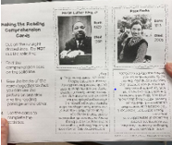
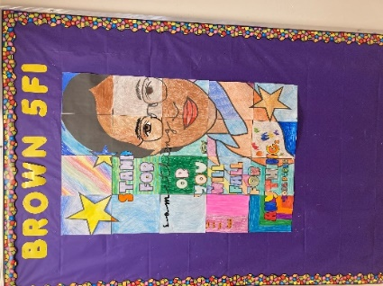
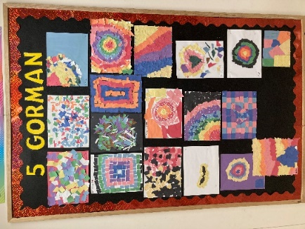
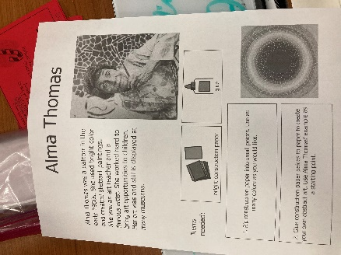

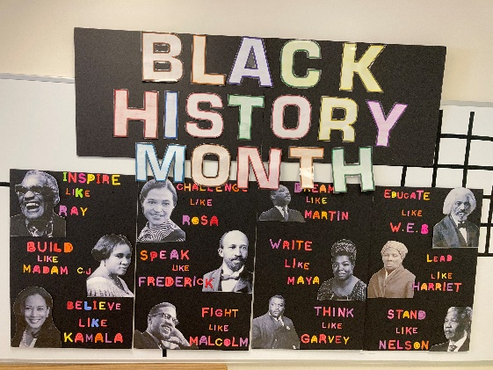
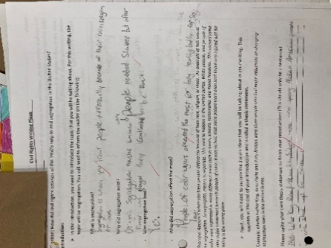
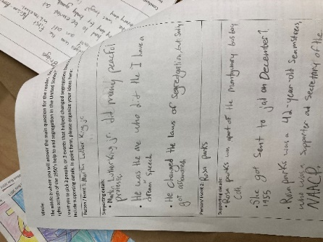

- Working Condition Funds- purchased 10 new teacher chairs.
- Staff Appreciation Week- Thank you to all families who brought in hot chocolate and coffee. Some of our students did cards of appreciation to the staff.
- New Covid Response for positive cases from EECD – currently a positive case is reported into a website with just case and date, staff or student and then the active case is registered on the ASD-W site. Now it is a questionnaire that is more in detail. Asks district, school, role, grade level, other work locations, date notified, any other relevant info. From there district notifies Public Health, District and Worksafe.
- Looking into a grant through EECD to have our buses paid for to go to Mactaquac for skating, sliding, snow shoeing, ducks unlimited. We are hoping to have this done on March 15 & 18 and hopefully it’s level 1 by then. Students would have lunch there. Waiting for more news on level 1 changes to the school.
- French Café Day – grant was written and we were given $1000 for this. We will do this during Winter Carnival week.
- Winter carnival- Snow much fun day, French culture Day, Crazy hair day, Bingo
- Pink Shirt Day-(Feb 23)- 2 Books were bought for all classes in French and in English (Be You & Be Kind). Activities have been prepared in both languages as well. More of a friendship day rather than a focus on bullying.
- Classes are getting ready for Term 2 Math Assessments and running records for reading levels.
- Starting to prepare for our transition to Middle school and for grade 1 to come up from Forest Hill.

Correspondence/Action Items:

Closing Comments: Thank you for the wonderful discussion and great ideas / items brought forward.

Please note we have 2 remaining meetings this school year. The next will be late March with the last meeting in April.

Date of Next Meeting: March 31, 2022

Adjournment: 7:16pm

Motioned by Ronnie Stewart, seconded by Colin Curry

